C (codes)

- 1D array code (sum of array)

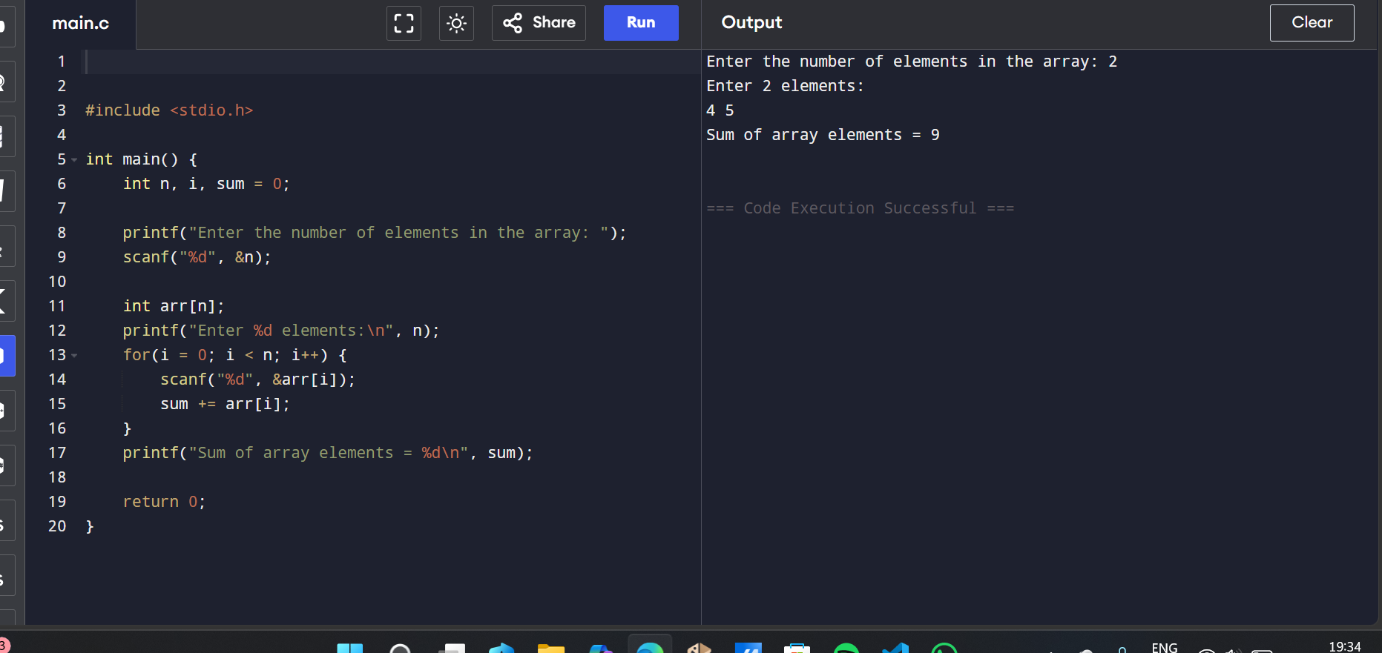

- Traversearray code
- 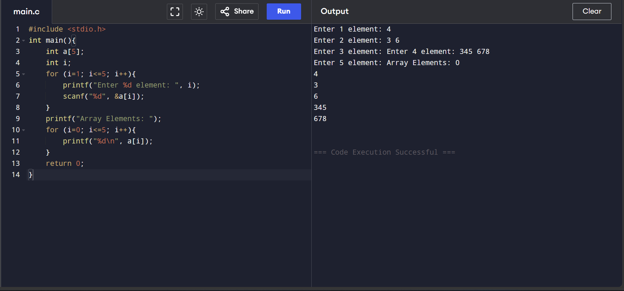
- 1D array print
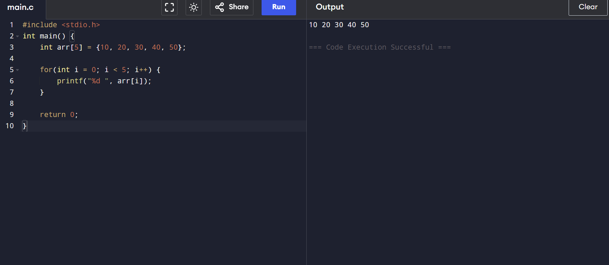

WAP to traverse one dimensional array.
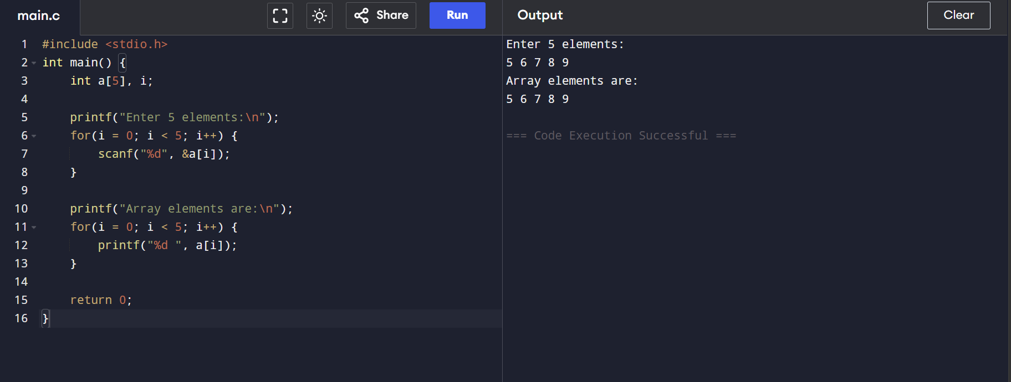

*Wap to find the sum of all array elements.
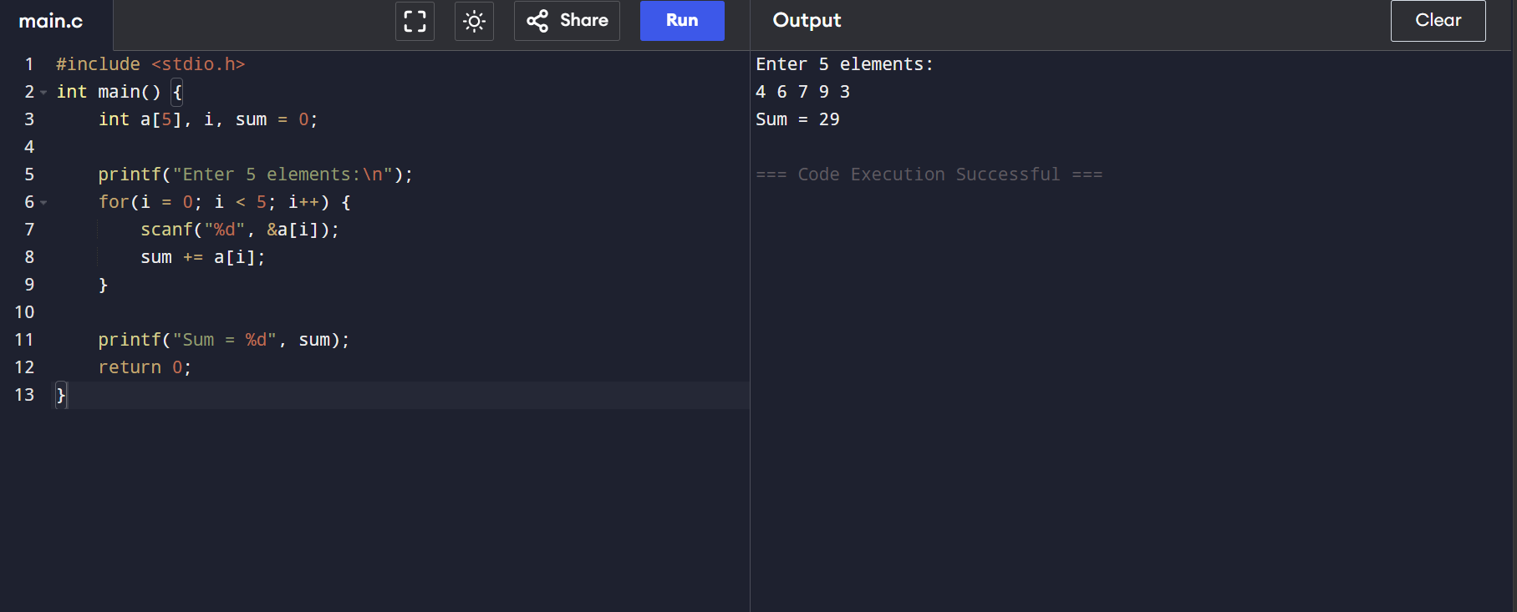

*Wap to count total number of even and odd elements in one dimensional array.
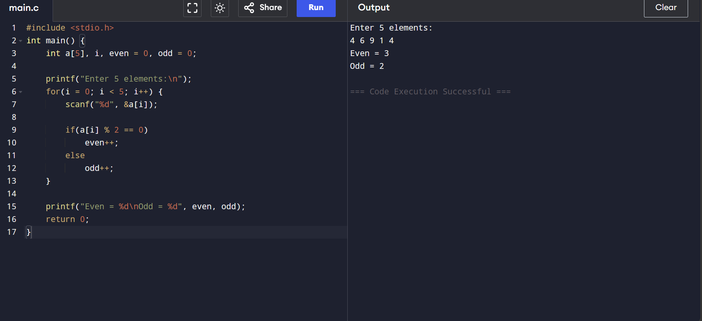

*WAP to count the total number of positive, negative and zero elements in 1D array.
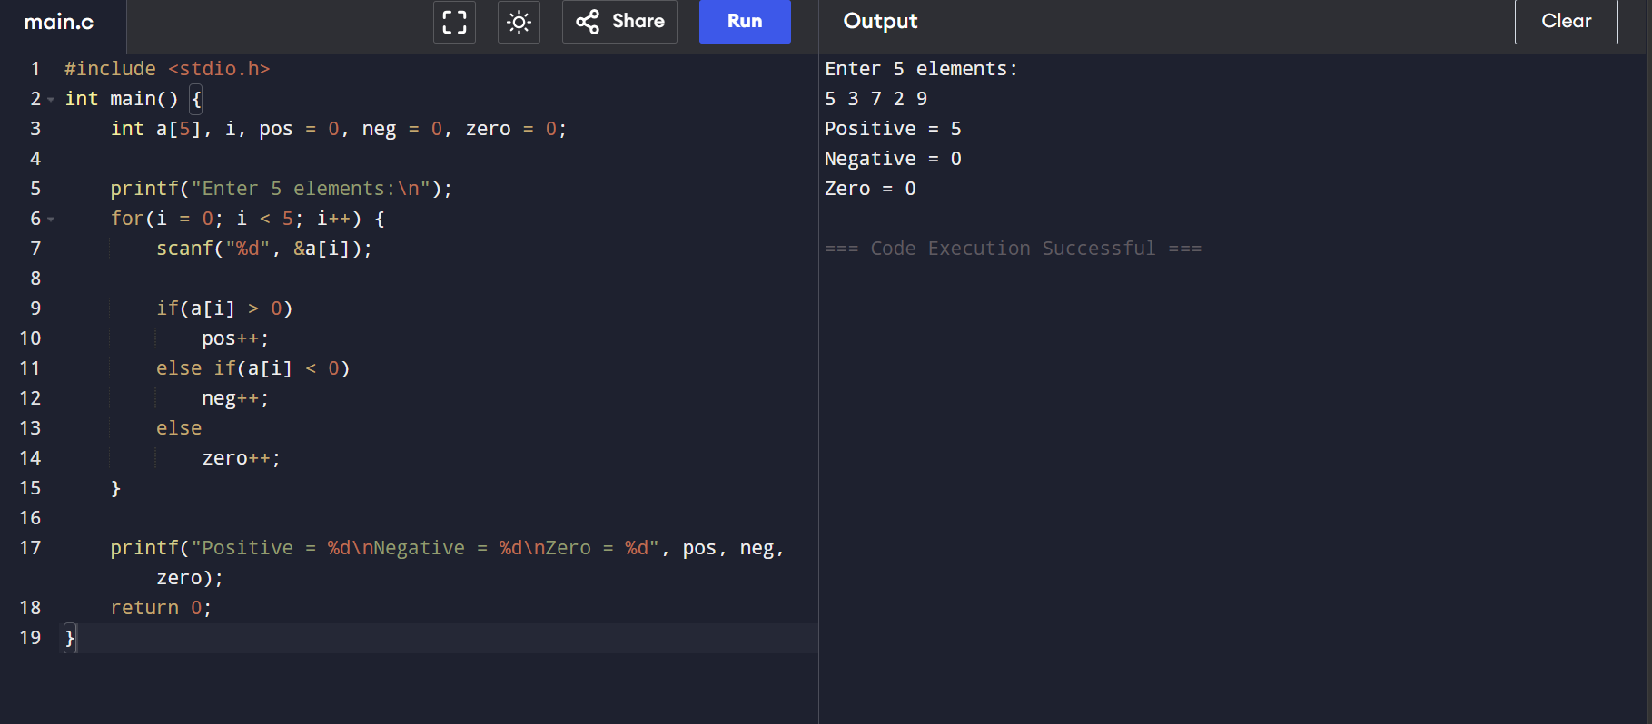

*WAP to insert an item at the given position in One Dimensional array
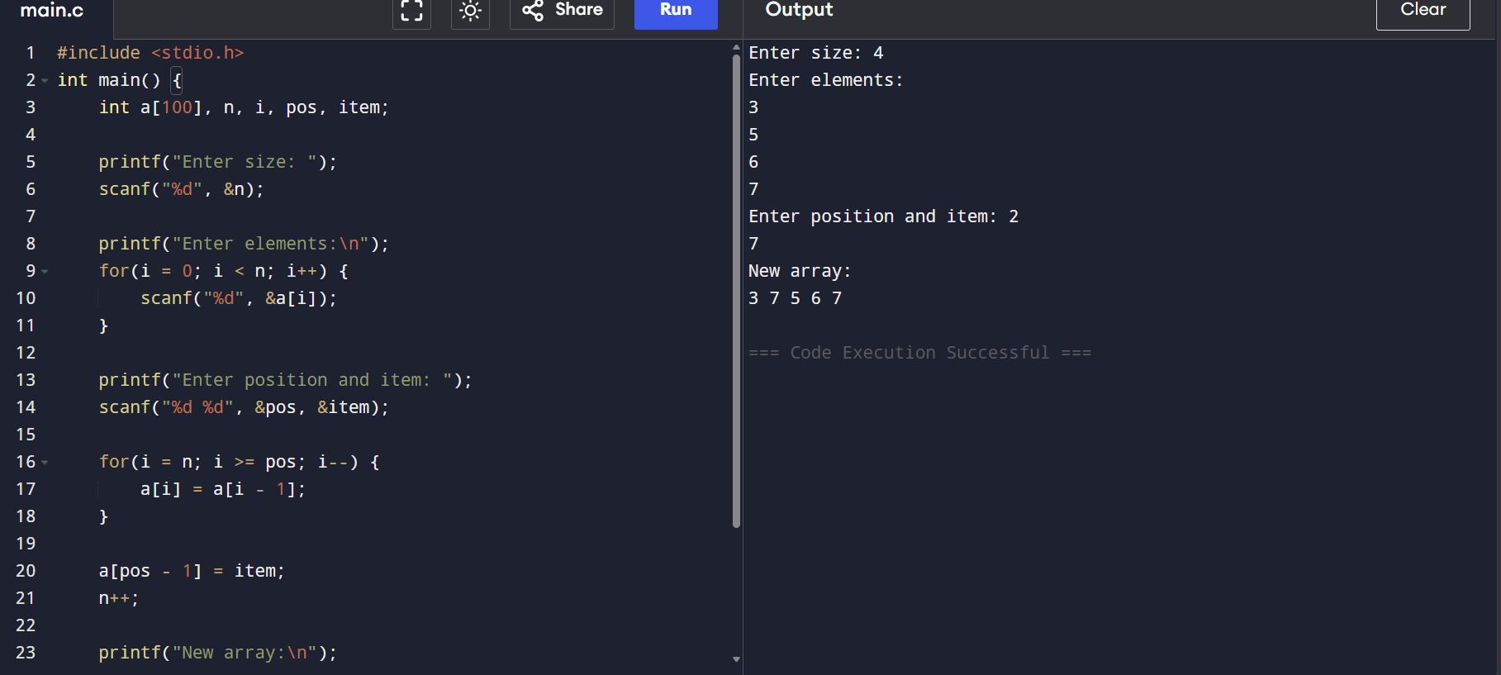

*WAP to delete one element from the given position in One Dimensional array
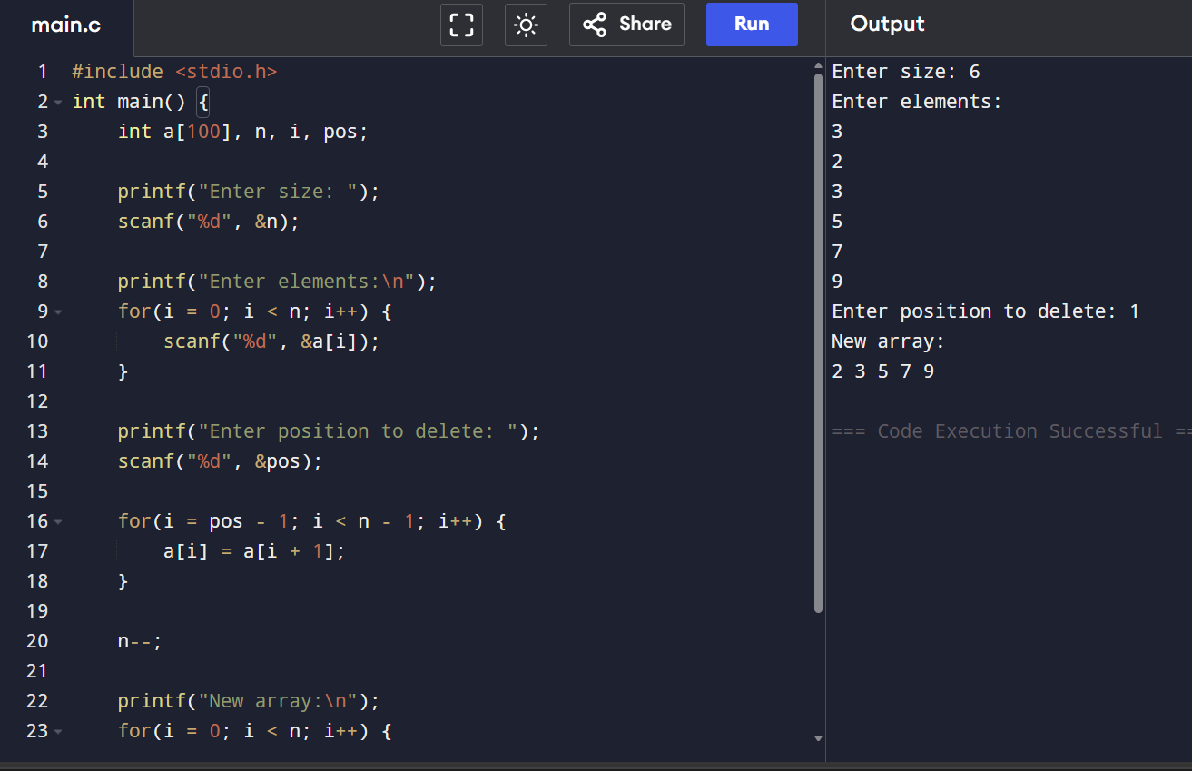

*WAP to implement linear search in ID array.
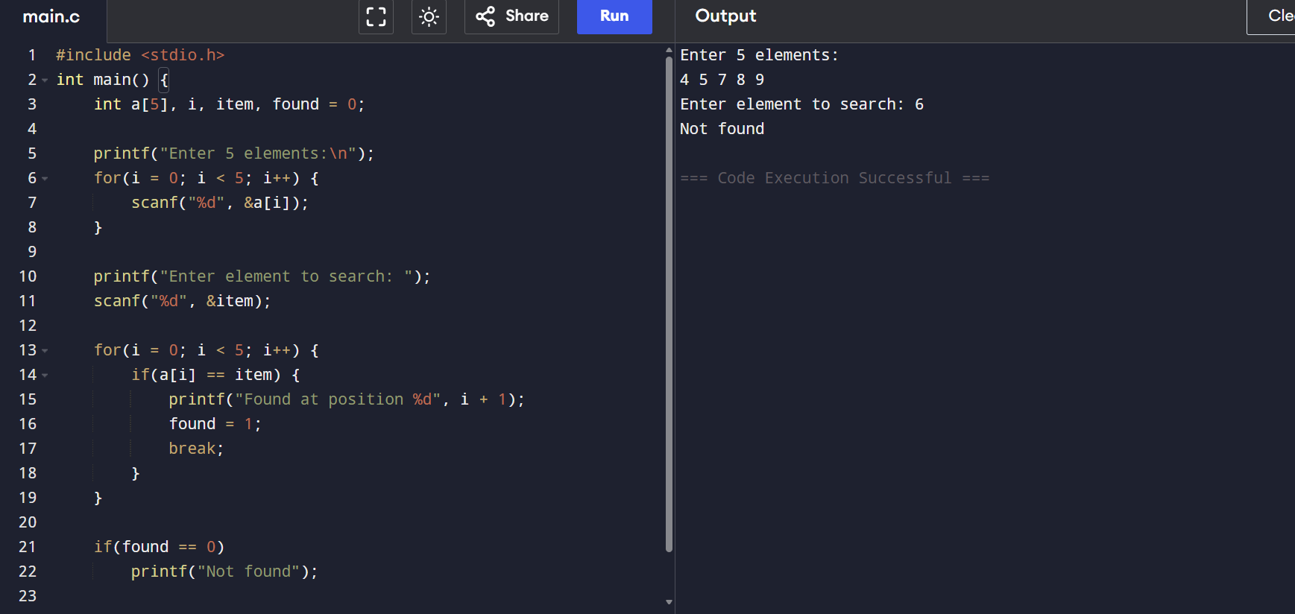

*WAP to implement binary search in 1D array.
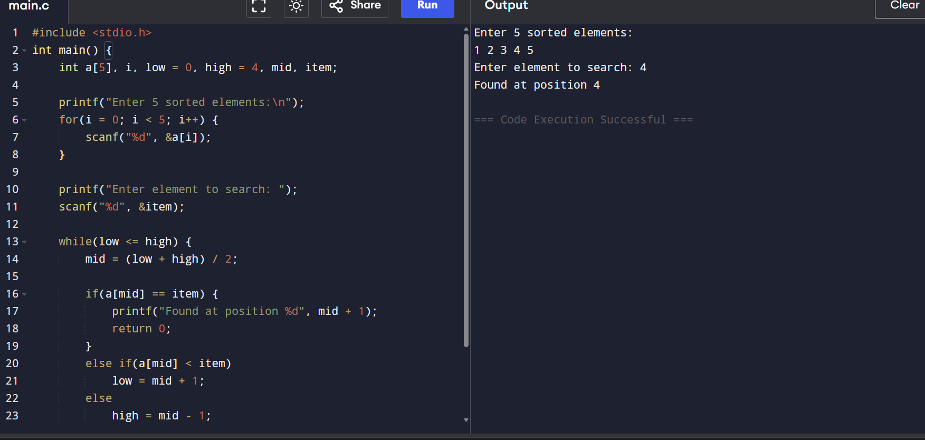

*WAP to check wheather the matrix is a Sparse Matrix or not.
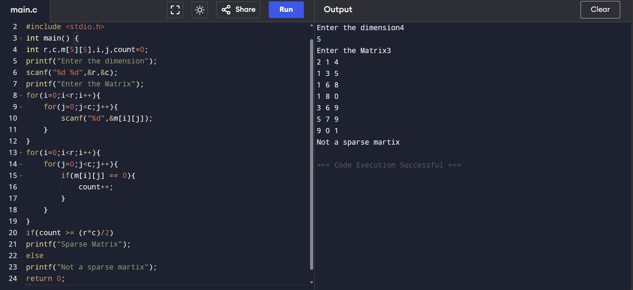

*WAP to traverse a 2D Matrix
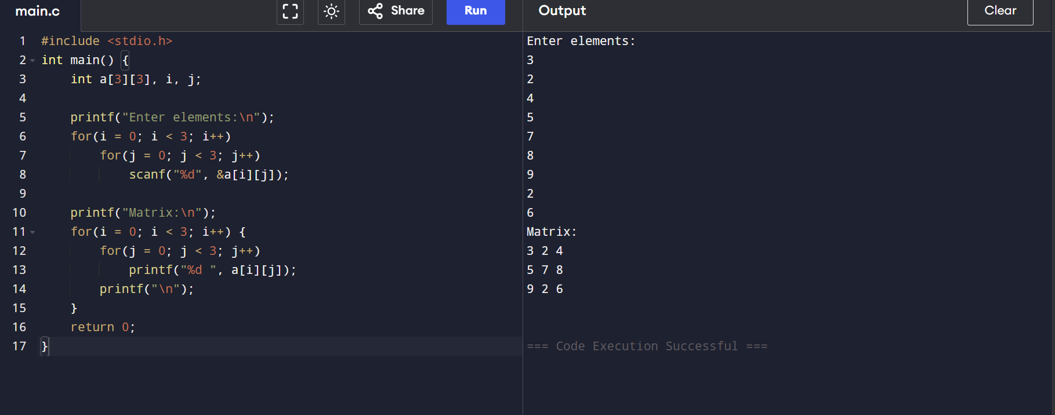

*WAP to find the sum of two matrices.
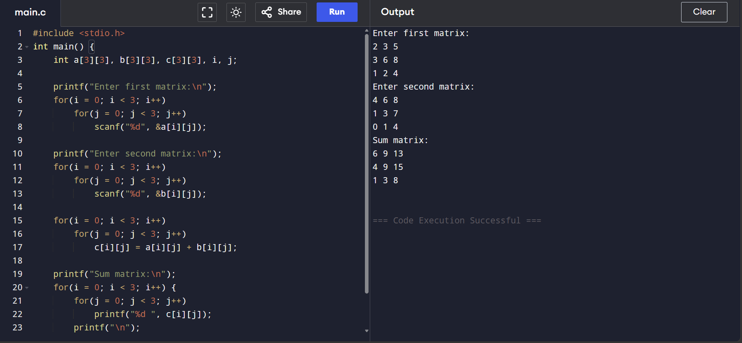

*WAP to find the multiplication of two matrices.
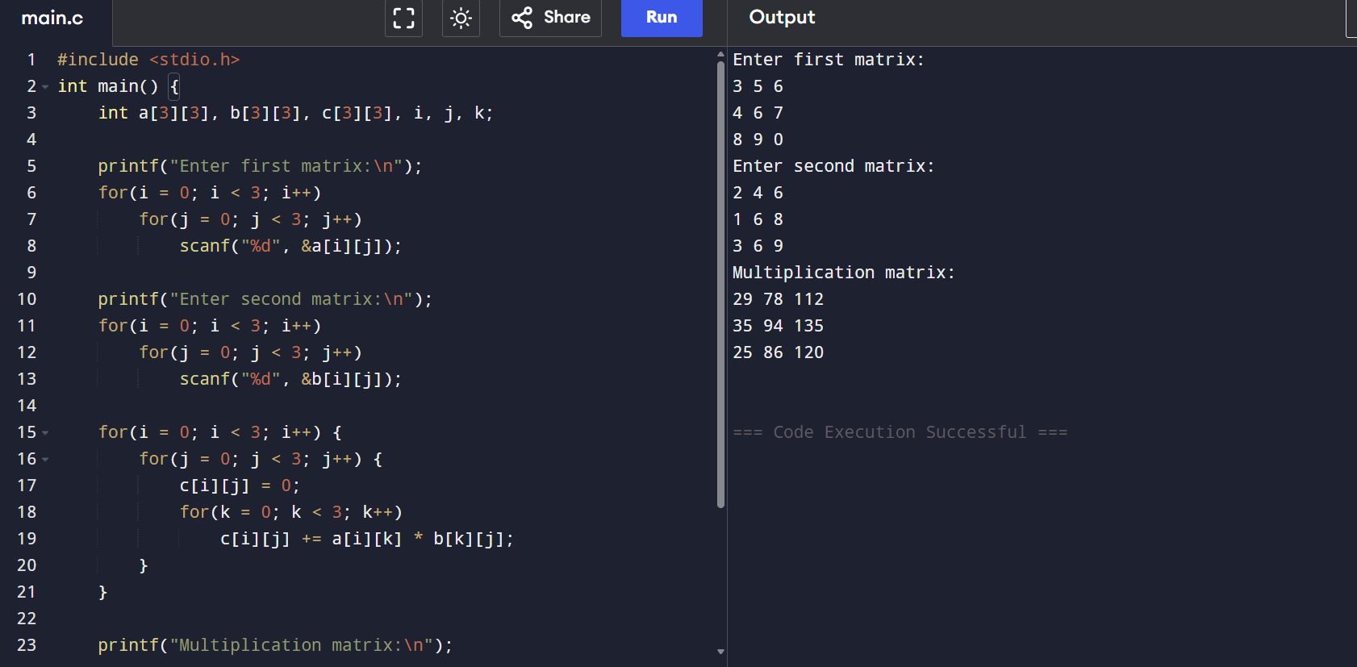

*WAP to find the sum of diagonal elements of a matrix.
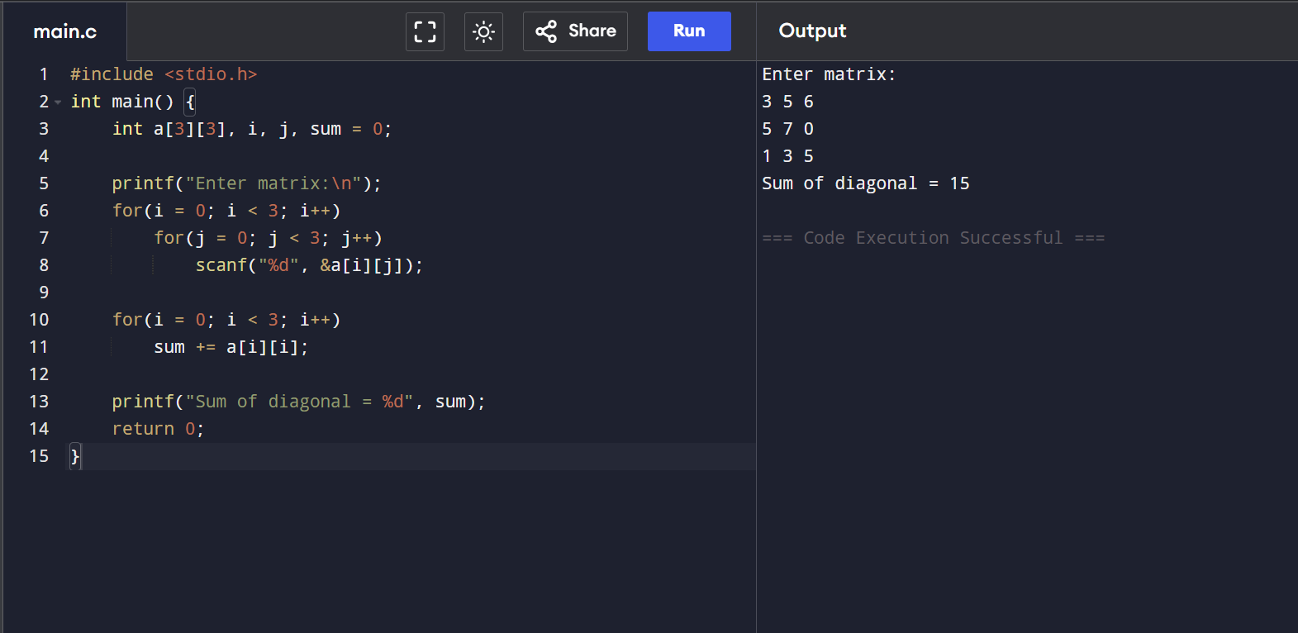

*WAP To find the transpose of inputted matrix.
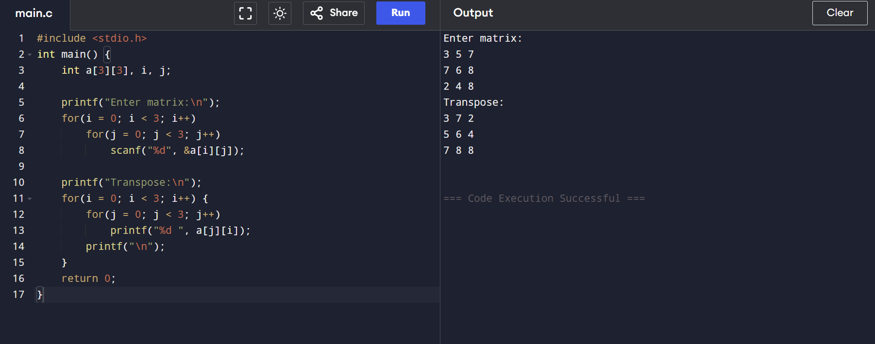
*WAP to check whether the inputted matrix is a Sparse matrix or not.
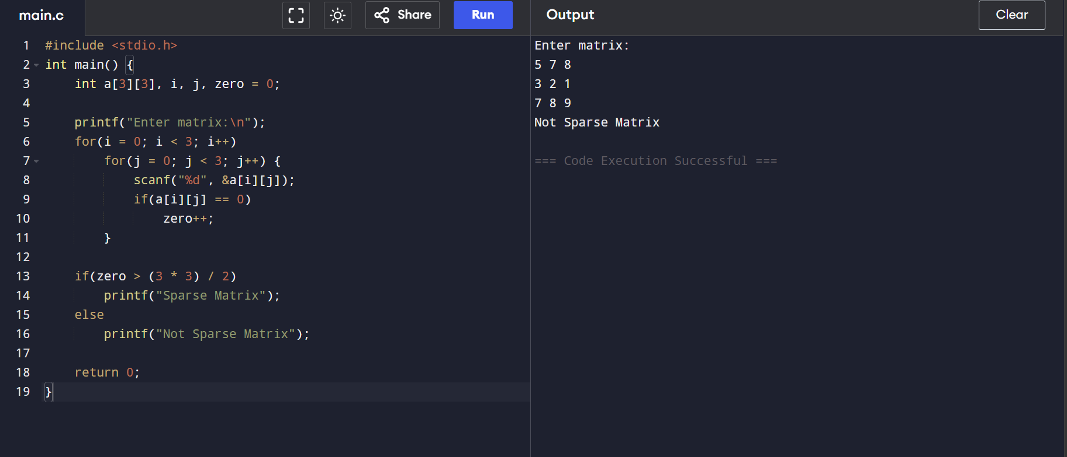

*WAP to check whether the inputted matrix is a Upper triangular matrix or not.
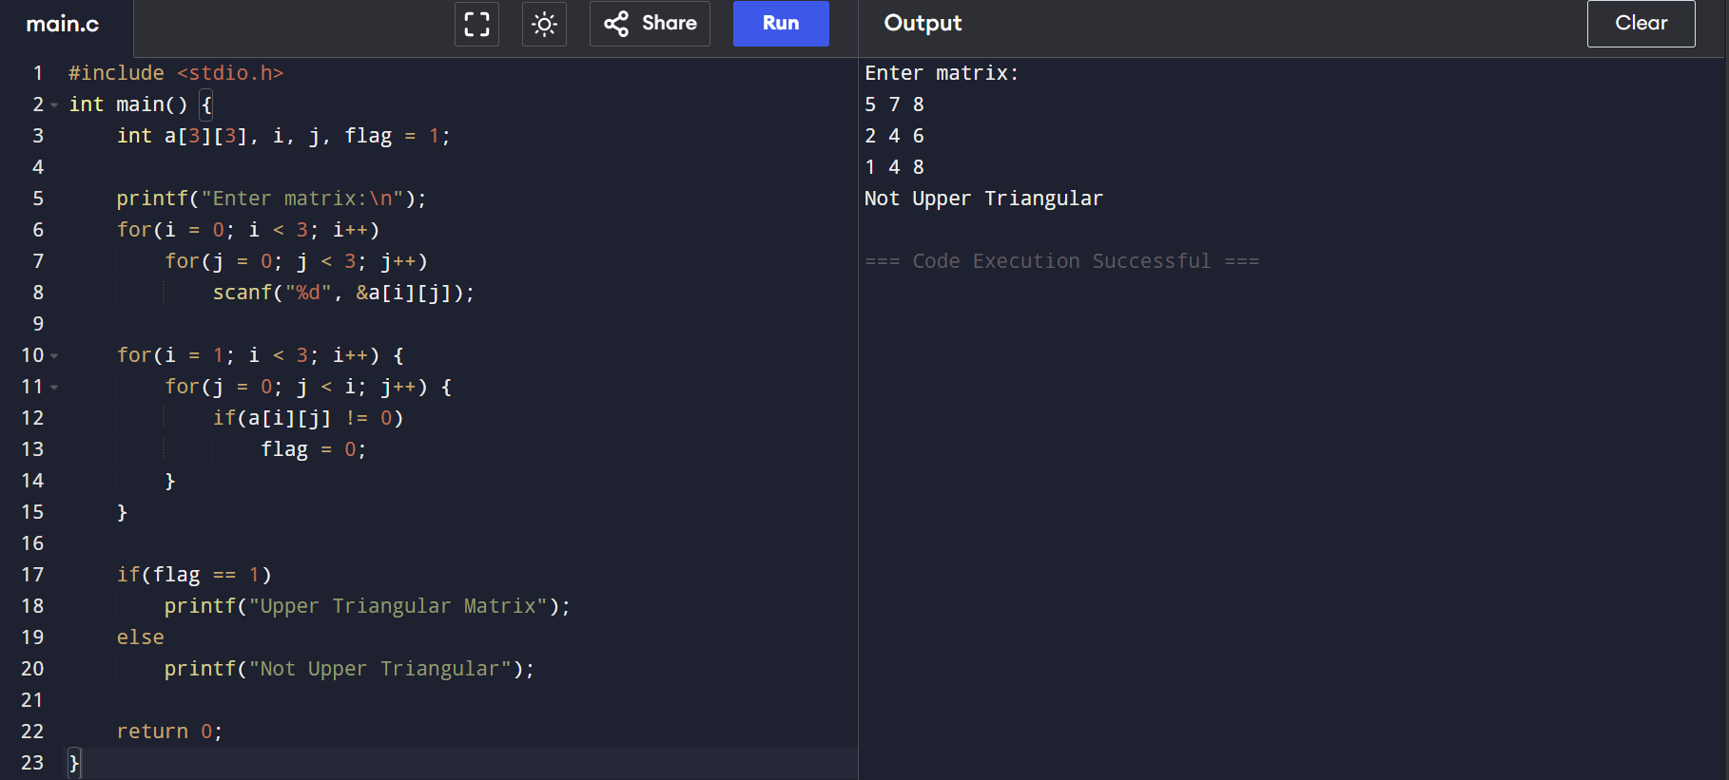

*WAP to check whether the inputted matrix is a Lower triangular matrix or not.

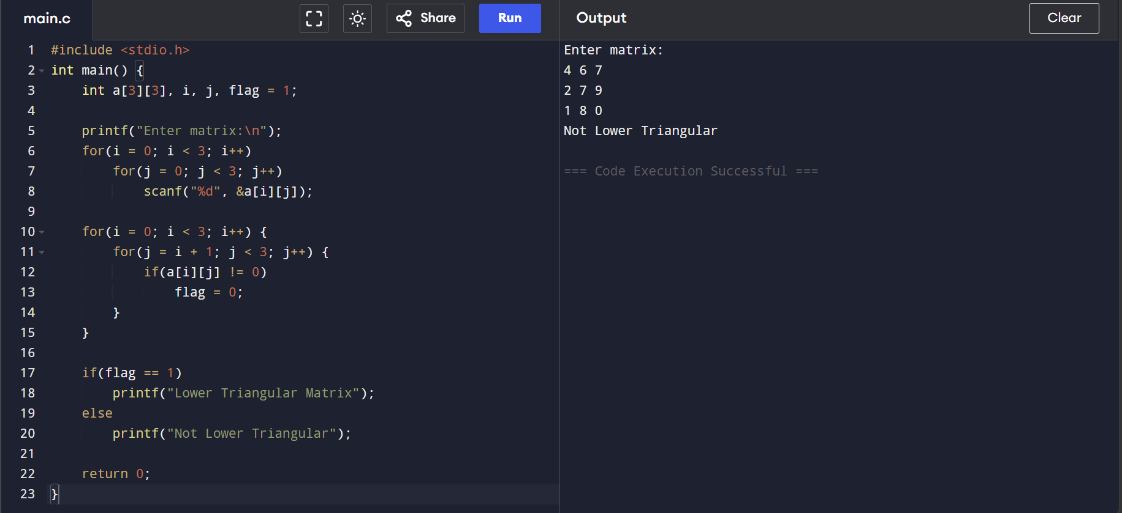

*WAP to implement Stack using 1D array by a Menu driven drive
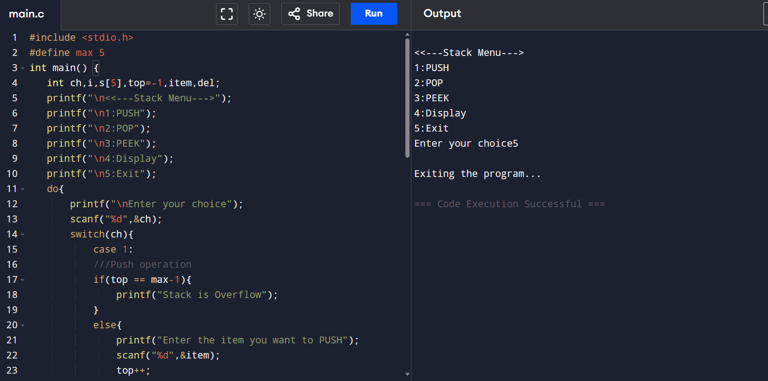
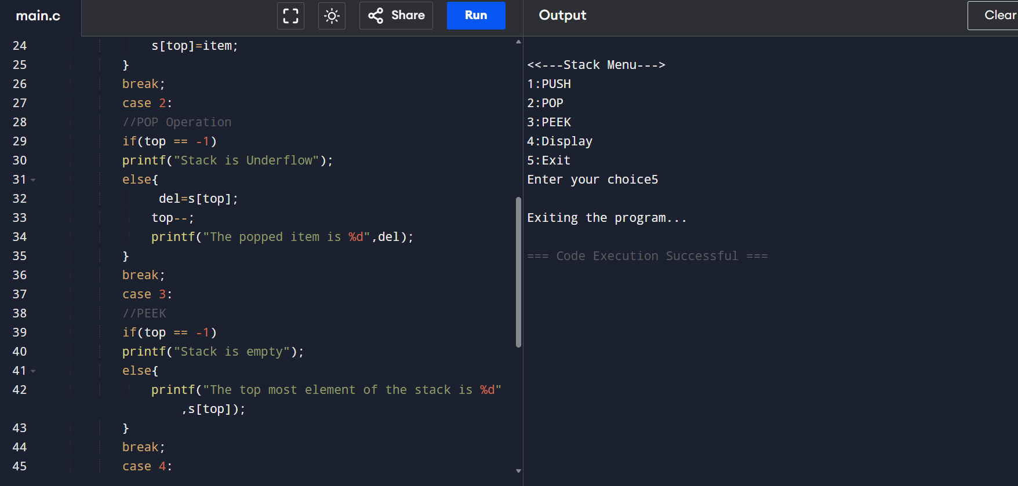
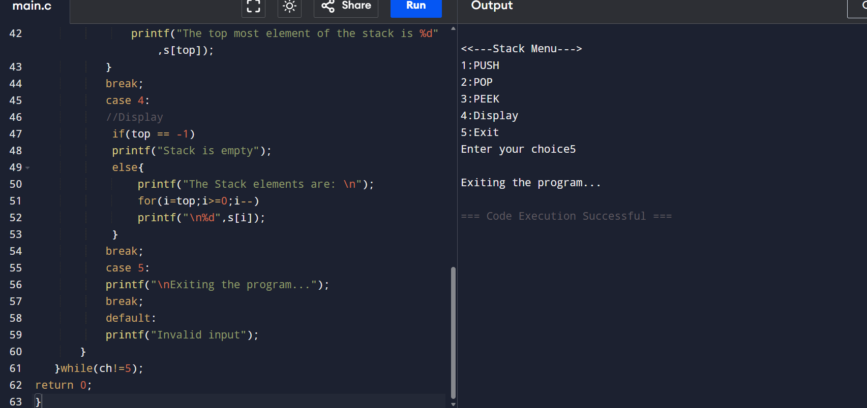

*the dimanssion of the matrix
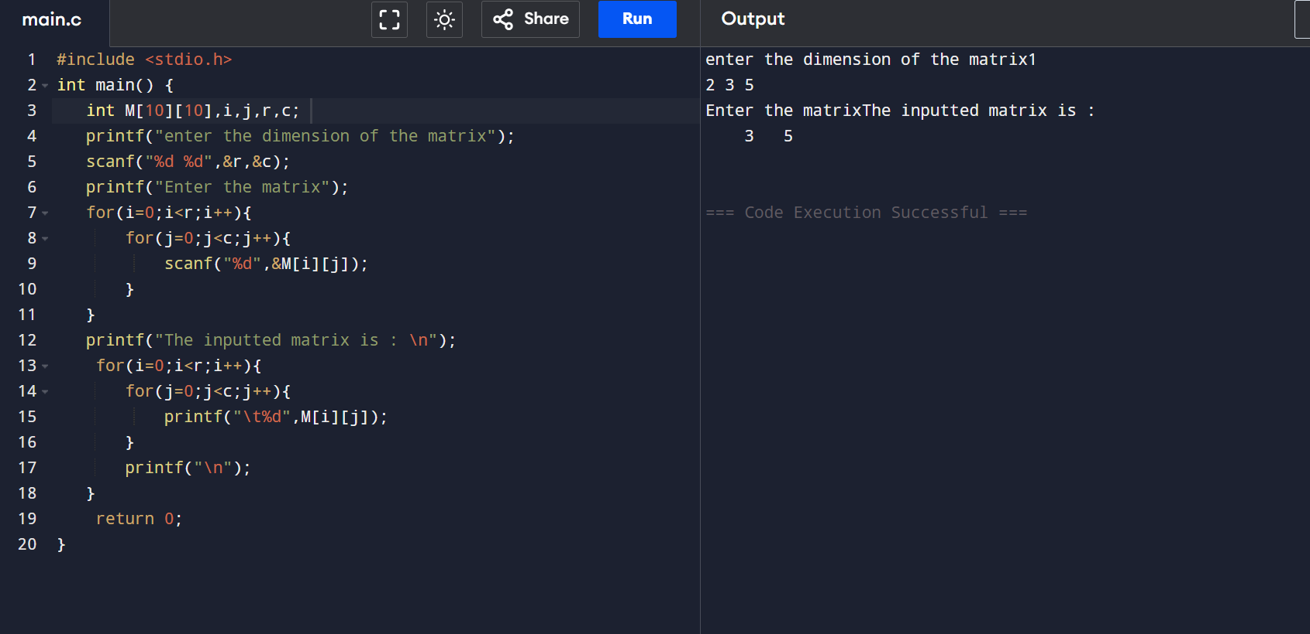

*Structure for a node
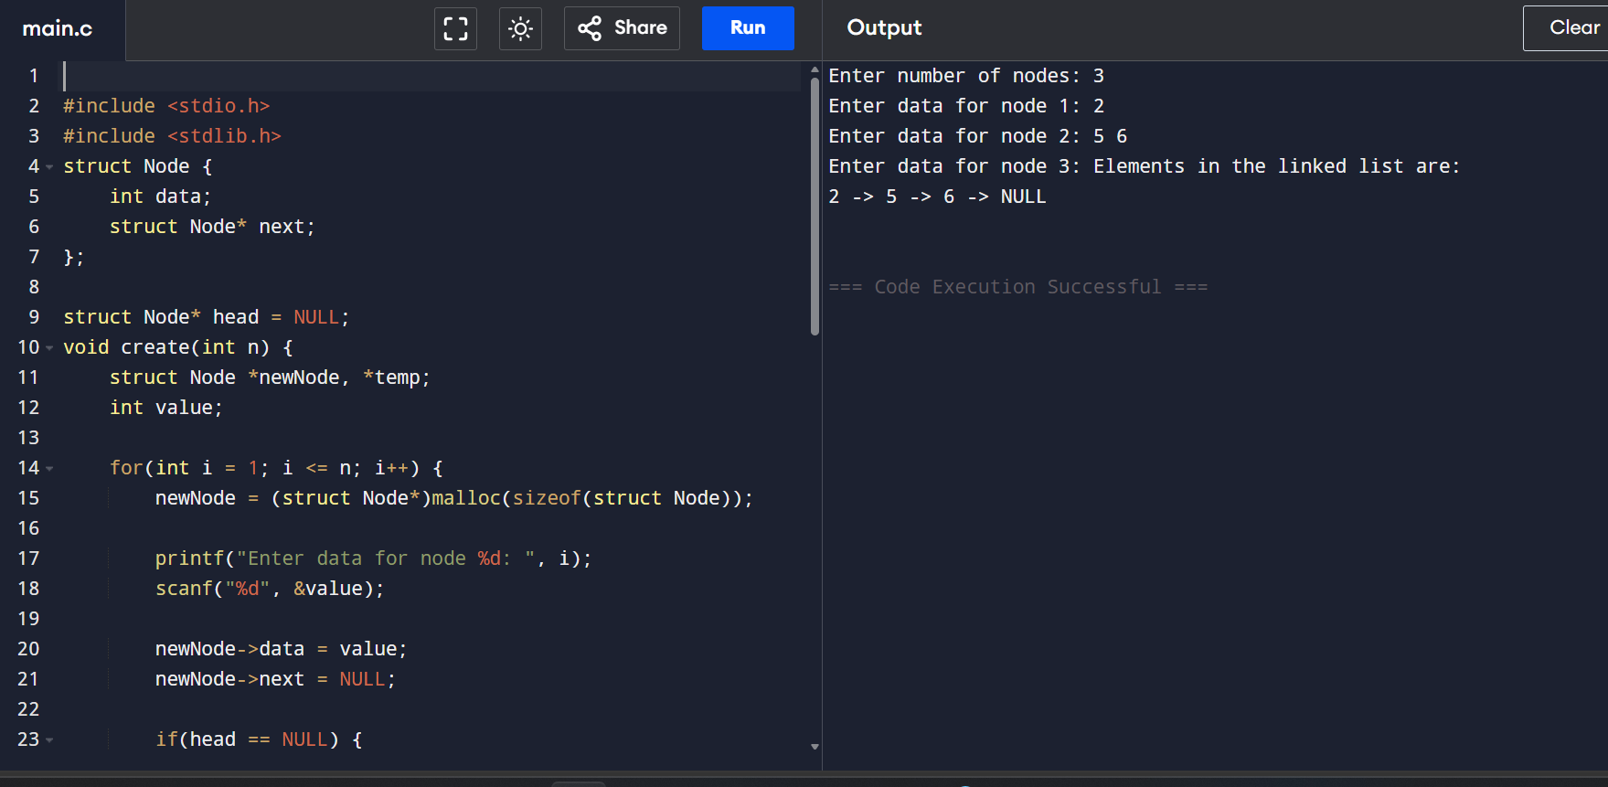
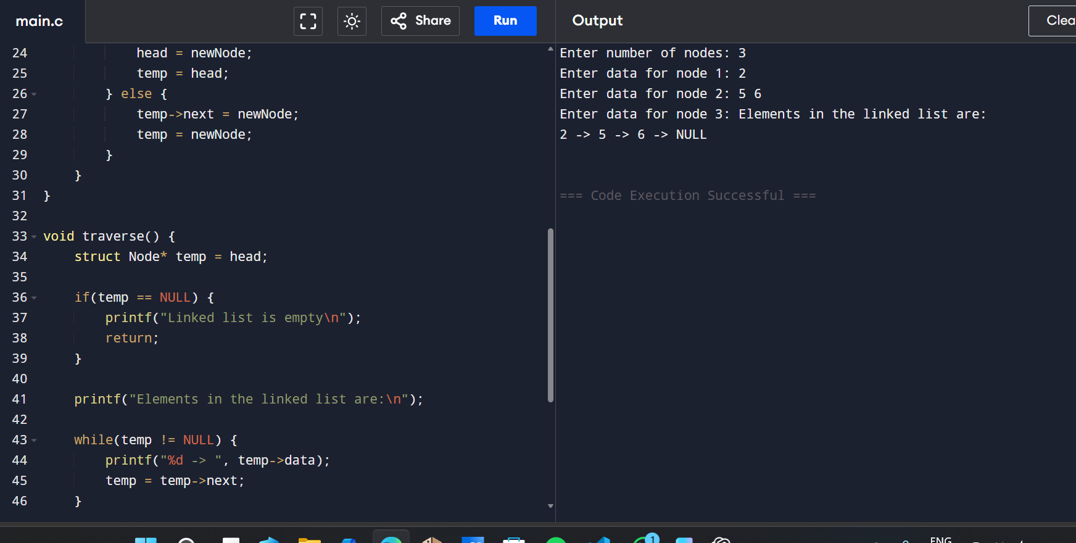
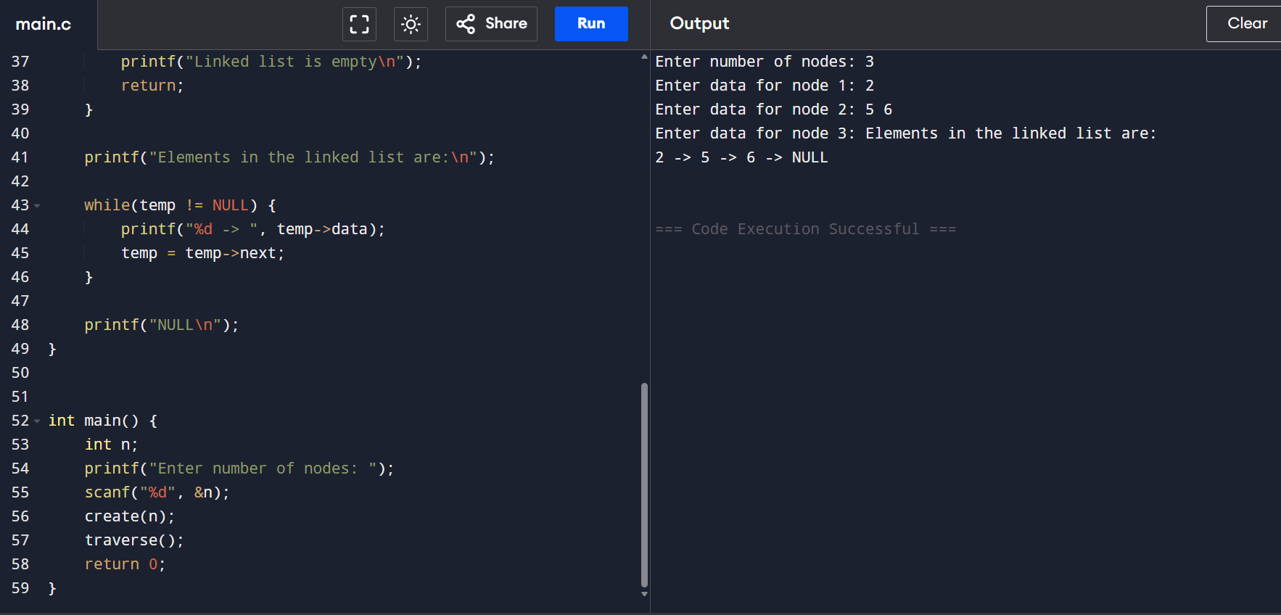

*Write a program to evaluate the Postfix Notation.
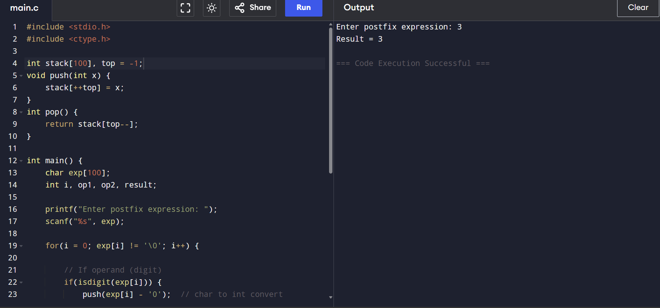
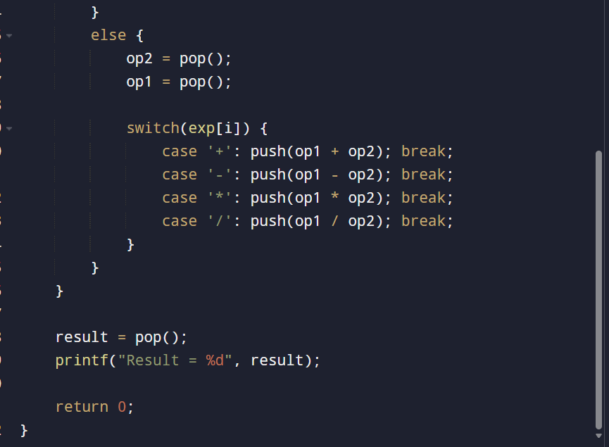

Write a program to convert infix notation into Postfix Notation.
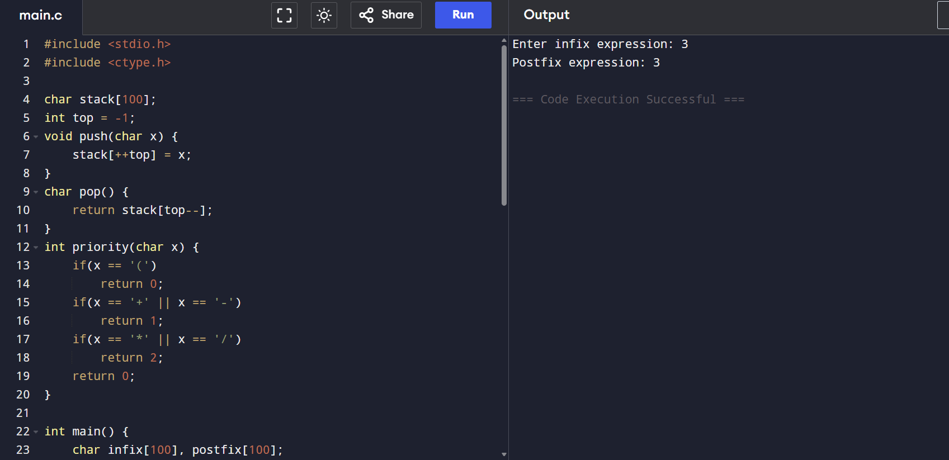
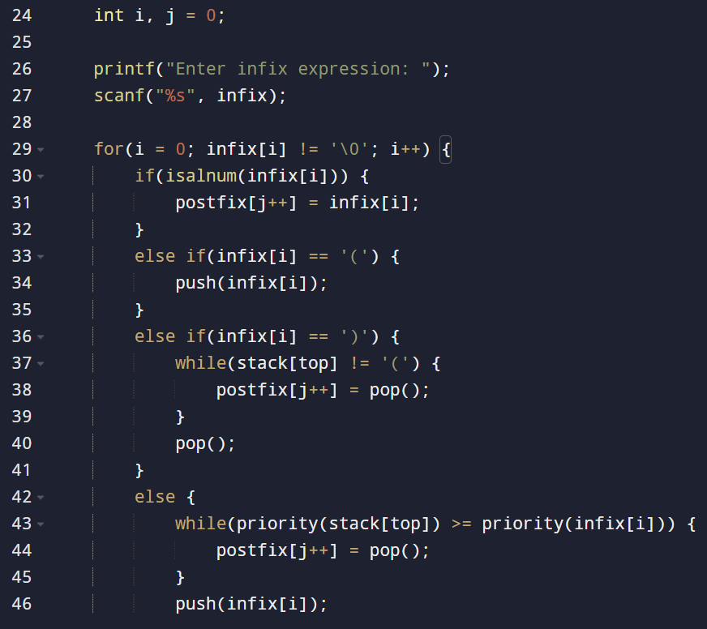
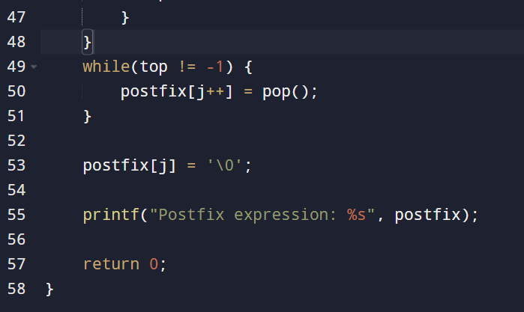
S

